- Connection between two computers using ethernet cable and data transfer

- Basic understanding concepts

- Computer A <==== Ethernet Cable ====> Computer B
Python Program <----TCP----> Python Program
- Layers : Python Program -> TCP -> IP -> Ethernet -> Cable
- Connection Requirements = port number + ip address
- Local host : When your program connects to 127.0.0.1, it's communicating with another program on the same computer, not over the network.
- Port: 5000
means:
"Talk to the program listening on port 5000 on computer 192.168.1.25."

- Creating Sockets
- Socket is like a telephone but used to talk with other programs on the same computer
- Use the “import socket” command to get access to functions like socket.socket() // It is like a phone existing but no call made yet.
- If we create a socket (my_socket = socket.socket()), and print it we will se an output as follows
<socket.socket fd=324, family=2, type=1, proto=0>

  - FD = file descriptor
Random number given by os to Socket to program, program uses this number as a handle to read data from the network
  - family=2
This means AF_INET which represents IPv4.
IPv4 addresses look like
192.168.1.10 Or 127.0.0.1
  - type=1
This means SOCK_STREAM which represents TCP.
  - proto=0
This simply means use the default protocol.

Although we don’t explicitly mansion, when we write my_socket = socket.socket() , we mean:-

my_socket = socket.socket(
socket.AF_INET,
socket.SOCK_STREAM
)
This is what a socket looks like

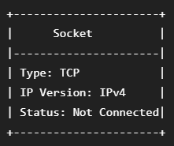

- Binding Sockets :-
- bind() tells the operating system:
"Associate this socket with this IP address and this port."
Syntax: socket.bind((IP_ADDRESS, PORT)) //Two Brackets
// Because bind() expects one argument, and that argument is a tuple

e.g. my_socket.bind(("127.0.0.1", 5000))
127.0.0.1 -> For local host (on host computer only no connection)
5000 -> generally use 5000-9000 (so there is no problem with reserved)

- Listen() :-
- listen() tells the operating system:
"I'm a server. Start waiting for connection requests."
// Without listen(), nobody can connect.

Listen(5) -> A number in listen tells :
"Allow up to 5 pending connection requests while I'm busy."
Waiting room size ≈ 5
The program ends??
- Because listen() doesn't wait. It only tells Windows:
"This socket is ready to accept connections."
Then Python immediately moves to the next line. Since there are no more lines,
- Program ends -> Socket Closes
- Accept() :-
-> It says:
Anology : "A client is knocking. Let them in."

client_socket, client_address = server_socket.accept()

Python tells the operating system:
"Pause here until someone connects."
- This is the first function we've used that blocks.

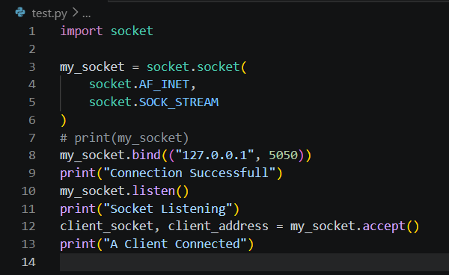
Code Till Now
From now on:
- server_socket continues accepting new connections.
- client_socket communicates with one specific client.
There are now two sockets on the server side itself, and there is one on the other side, that is client socket,
Now there are THREE sockets
This is the key idea.

SERVER SIDE
server_socket
(listens forever)
client_socket
(talks to Client)
CLIENT SIDE
Client
(talks to Server)
- First TCP Connection (Creating Client Socket):-

- Firstly Created a client socket (different process) that will connect to server process and will be given a port number automatically by os when it connects to a server.
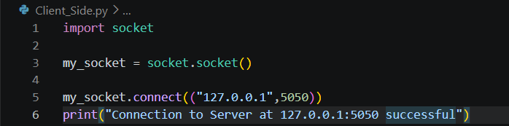

There is no bind and listen as it doesn’t need a port no. os will provide it, and it doesn’t need to listen as it will only req to connect to server.

CLIENT SERVER

SYN ----------------------------> This is the three way handshake that
Happens in the background..
<--------------------- SYN + ACK

ACK ---------------------------->
Running on separate terminals both the files, it results in a connection, but, the connection ends, as there was nothing to do, and python script ends
- One important observation is that, It was the client side who’s script ended first, not server’s, once client’s socket was destroyed, because of that server code was ended as there was no longer a connection.

- Sending Messages send() receive() :-

- We can’t directly send data, TCP understands only bits and not strings and stuff, so we have to encode and decode that data on client and server side.
The Journey can be understood as follows :-
Client -> "Hello" -> encode() -> b'Hello'> TCP -> Ethernet -> Cable -> Server -> recv() -> b'Hello' -> decode() -> "Hello"
One Important note is that :-
Imagine water flowing through a pipe.
HelloWorldPython
The server might read: --- HelloWor
then --- ldPython
or
HelloWorldPython
depending on timing and buffer sizes.
For now, because our messages are tiny and we only send once, everything appears as one piece.
For a proper chat application, knowledge on how to define message boundaries is necessary. (later)
Send - message = "Hello Tejas"
my_socket.send(message.encode())
Receive - data = client_socket.recv(1024)
** 1024 is the max amount of data Receiver wants to read from its receive
buffer

- Two-Way Communication :-

- Simply writing receive and send on both sides will work, but it is not how a normal program should work, that’s because,

-> if both are at recv() state, it’s a deadlock, even if there is a send() after the receive command, it will not execute and deadlock will occur. (Not the best way to implement it)

We can’t just write
while True: message = input("You: ")
client_socket.send(message.encode()) On both sides

This is because then both will be stuck on send (or receive) and not move forward.

So, we will use the concept of threads to create two threads for each, one will listen and other will send if there is data.
Also, even though python has GIL (Global interprittor Lock) it works well for I/O programs (chat applications like this) but not ideal for CPU heavy calculative tasks

- Threads :-
Program

Worker 1
↓
Keyboard
↓
Send

Worker 2
↓
Receive
↓
Display

Each (client and server) will have both the threads and hence will be to able to listen
and send simultaneously
(Threads was not very familier topic to me, so I had to give some time to understand threading, and understood that the sending is done by the main thread, that is there in our main code, we have just created another secondary thread that works to receive data.)

Server side code Till Now
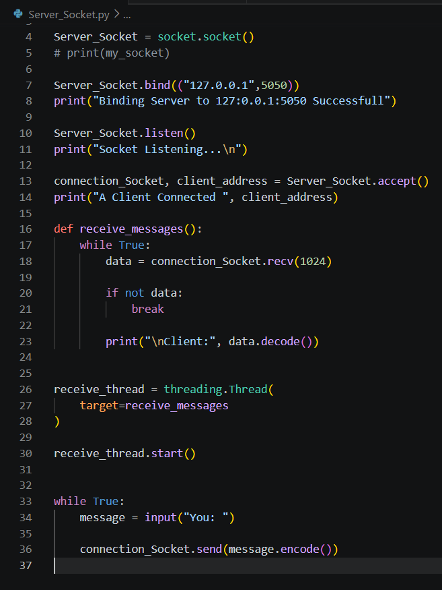
Client Side code Till Now
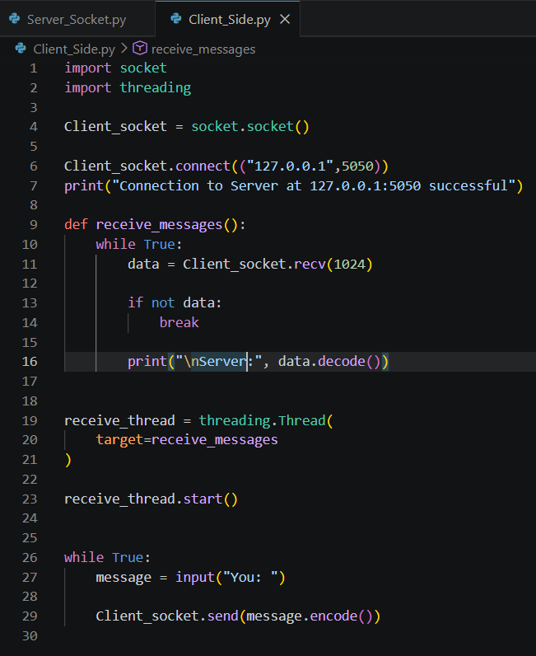

- Although a problem soon arose as can be seen below, this was caused due to what I understand is “Race Condition”. For our problem statement, it will be automatically fixed when we create a UI, and don’t need to focus on it.
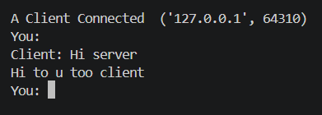

- Ending the Connection Properly :-
- For proper ending of both sockets, following changes were made to the receive and send thread of both the functions
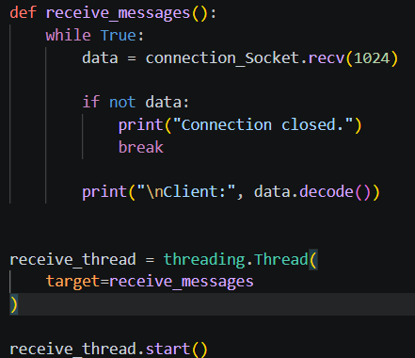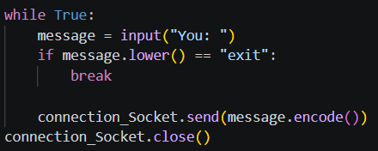

- Need of Protocol and its creation :-

- Till now as we were sending small messages it wasn’t a problem, but TCP is a byte stream protocol and it won’t be able to send messages like “Hi my name is Tejas” properly, so we have to be able to find where each message as it is not message stream protocol.

- For example :
WhatsApp defines its own protocol. The TCP layer only delivers bytes.
The application decides: "This sequence of bytes is one message."

The Protocol I am gonna implement is Length Prefix and it will look like :-
+-------------+------------------+
| Length | Message |
+-------------+------------------+
But we wont be able to undersatand the size of actual header for example, in 25Hello is 2 size and 5Hello message or 25 is size??
-> for this problem we will use fixed size Header. (4 Bytes)
And for this, we will use structs (converting numbers into bytes)
Python Integer -> struct -> Bytes

e.g.
import struct length = 5
header = struct.pack("!I", length)
print(header)
This is format string syntax.
- ! → Network byte order (big-endian)
- I → Unsigned 4-byte integer

Our Future send_message()
will do something like this:
- Convert the message to bytes.
- Find its length.
- Pack the length into a 4-byte header.
- Send the header.
- Send the message bytes.
Our Future receive_message()
will work in the reverse order:
- Read exactly 4 bytes (the header).
- Convert those 4 bytes back into an integer.
- Read exactly that many bytes (the message).
- Decode them back into text

